COMMISSION MODULE
Technical Inventory & Implementation Baseline
Enterprise Architecture Handoff Document

Field | Detail
Project | flow-link-docs — Future Link Education Platform
Stack | Vite + React + TypeScript + Supabase (PostgreSQL RPCs, RLS, Edge Functions)
Module scope | Institution partner commissions — Phases 1, 2A, 2B + Performance Hub overlay
Audit date | 30 June 2026
Audit type | Documentation & architecture audit — no code modified
Guiding principle | REUSE → EXTEND → CREATE
Prepared for handoff to an enterprise product architect.
All conclusions are tied to observed files, migrations, and documentation; unverified behavior is marked “Not Found.”

Contents
1. Executive Summary
2. Database Architecture
3. Business Process Architecture
4. Backend Architecture
5. Frontend Architecture
6. Existing Business Logic
7. APIs, Hooks & Services
8. Reusable Components
9. Current User Interface
10. Technical Debt
11. Reuse Analysis (Evidence-Based)
12. Extension Points
13. Cross-Module Dependencies
14. Deliverables Summary & Handoff Notes
Note: this document uses styled headings; open in Word and update fields (Ctrl/Cmd+A, F9) to generate a page-numbered, clickable table of contents.

1. Executive Summary
The Commission module automates institution partner commissions for an international education agency: from the commercial agreement with a partner institution, through per-student commission calculation and eligibility, into claims, invoicing, receipt posting, and aggregator reconciliation. It is a Supabase-first application — persistence, business logic, access control, and workflow all run through PostgreSQL tables, RPC functions, row-level security, and Edge Functions, with a React institution-tab workspace as the operational core.
Overall completion is estimated at ~72% for institution partner-commission operations through Phase 2B. The three delivered phases (Phase 1 lifecycle, Phase 2A receipts, Phase 2B aggregator) are internally documented as UAT-ready. Enterprise integrations — Finance general-ledger posting, CRM automation, and additional commission channels (referral, B2B, agent) — remain largely unbuilt and are documented as out-of-scope or missing.

1.1 Completion by area
Area | Est. | Evidence
Institution setup (billing, agreements, eligibility, rules) | ~90% | Phase 1 UAT readiness doc; UI panels exist
Student lifecycle (eligibility, hold, transfer, snapshots) | ~85% | RPCs + CommissionLifecycleDialog; custom trigger not built
Claims & invoicing | ~80% | ClaimsPanel: recalc, submit, invoice; manual client link missing
Receipt posting & allocation (Phase 2A) | ~85% | Full receipt schema, RPCs, wizard; no accounting bridge
Aggregator workbench (Phase 2B) | ~75% | Workbench + RPCs; 2B tables missing from generated types.ts
Performance Hub finance overlay | ~60% | Read-only INR ledger; operations stay in /commissions
CRM auto-integration | ~5% | clientIntegrationBridge.ts dormant (BRIDGE_ENABLED = false)
Finance GL posting | ~0% | accounting_journal_id column exists; no live bridge
Global admin / reports / pending-claims screens | ~25% | Global /commissions is summary-only; dedicated screens Not Found

Bottom line: Conditionally UAT-ready for institution partner commission operations (Phases 1, 2A, 2B). Not yet enterprise-production-ready for full Finance integration, CRM automation, or multi-channel commission types without the additional work documented below.

1.2 Production-ready features (observed)
- Institution billing profiles (BillingProfilesPanel, upi_billing_profiles).
- Agreement CRUD with version effective-dating (AgreementsPanel).
- Eligibility config publish workflow (EligibilityConfigPanel, fn_evaluate_eligibility).
- Commission rules with publish gate and simulator (CommissionsPanel, fn_publish_commission_rules).
- Partnership route → default-commission link (PartnershipRoutesPanel).
- Student recalculate, mark-eligible, hold/release, transfer (ClaimsPanel, CommissionLifecycleDialog).
- Immutable commission snapshots (DB trigger blocks UPDATE/DELETE).
- Claim submit + invoice generation + PDF/CSV export (ClaimsPanel, claimsExport.ts).
- Receipt lifecycle draft → ready → posted → void (CommissionReceiptWizard, receipt RPCs).
- Aggregator remittance batches + aggregator invoices (AggregatorWorkbenchPage).
- Counselor-safe client status view (ClientCommissionStatusPanel, v_client_commission_status).
- Performance Hub commission ledger with INR consolidation (PerformanceCommissions).

1.3 Partially implemented features
- Client ↔ commission-student linking (manual client_id only; UI button disabled — “Coming soon”).
- Custom eligibility trigger (returns custom_not_implemented in both TypeScript and SQL).
- FX review on receipts (implemented in RPCs; exercised only in multi-currency allocation scenarios).
- Aggregator statement upload (RPC works; UI label reads “placeholder upload”).
- Invoice numbering (FLC-YYYY-AUTO-* placeholder per UAT doc).
- Phase 2B type safety (aggregator tables accessed via `as any` casts).
- Clawback columns exist on upi_commission_students; clawback logic is Not Found in application code.

1.4 Placeholder / stub features
- CRM event bridge (src/institutions/planned/clientIntegrationBridge.ts — all handlers are TODO stubs).
- Institution Claim Eligibility Rules (backlog doc only — distinct from Phase 1 eligibility config).
- Accounting bridge (explicitly out of Phase 1/2A scope in UAT docs).
- Bonus engine (bonuses modeled as commission rules, not a separate engine).
- Forecast engine and credit notes (documented out of scope).

1.5 Major dependencies
Dependency | Role
Supabase | All persistence, RPCs, RLS, storage
Institution module | Host UI, partnership routes, aggregators, documents
Auth / RBAC | isCommissionAdmin, isAccountingMember, useModulePermission(“commissions”), can_view_upi_confidential
Performance Hub | Read-only overlay; FX rates from fx_rates
Commercial Agreement Engine (CAE) | upi_agreements templates, settlement eligibility
AI Edge Functions | upi-extract-commission-sheet, upi-analyze-agreement

1.6 Known limitations
- No REST/OpenAPI layer — Supabase client + RPCs only.
- No commission-specific background jobs or queue workers (Not Found).
- No materialized views (Not Found).
- Finance posting does not create accounting journals on receipt post.
- Student rows are not auto-created from CRM/admission events.
- Global dashboard lacks drill-down navigation into institution workflows.
- Separate Commission Administration and Reports routes are Not Found.

2. Database Architecture
The commission schema is delivered across sequential Supabase migrations (20260723120000 through 20260815120500), with earlier UPI institution migrations providing host tables. The concatenated DDL is available in docs/database/COMMISSION_SCHEMA.sql. All commission entities are prefixed upi_commission* or scoped under the upi_ namespace.

2.1 Core setup & master tables
Table | PK | Purpose
upi_agreements | id uuid | Institution commercial agreements
upi_agreement_versions | id uuid | Versioned agreement files/terms
upi_billing_profiles | id uuid | Billing entities (institution or aggregator-scoped)
upi_commissions | id uuid | Commission plan definitions (no separate plan table)
upi_commission_rules | id uuid | Scoped payout rules (slabs, bonuses, conditions)
upi_commission_eligibility_configs | id uuid | Published student eligibility triggers
upi_commission_hold_reasons | code text | 11 hold/deferral reason codes
upi_commission_periods | code text | Commission period master (application → year_1)
upi_partnership_routes | id uuid | Routes with default_commission_id FK
upi_aggregators | id uuid | Aggregator partners (Phase 2B)

2.2 Operational / transactional tables
Table | PK | Purpose
upi_claim_cycles | id uuid | Claim submission cycles per institution
upi_commission_students | id uuid | Per-student commission row (3-axis lifecycle)
upi_commission_snapshots | id uuid | Immutable calculation audit records
upi_commission_transfer_events | id uuid | Transfer / amendment / cancellation events
upi_commission_invoices | id uuid | Commission invoices to institutions
upi_invoice_line_items | id uuid | Invoice lines linked to students/snapshots
upi_commission_receipts | id uuid | Payment receipts (Phase 2A)
upi_commission_receipt_invoice_allocations | id uuid | Receipt → invoice allocation
upi_commission_receipt_student_allocations | id uuid | Receipt → student allocation
upi_commission_receipt_attachments | id uuid | Receipt file attachments
upi_commission_remittance_batches | id uuid | Remittance batch grouping (Phase 2B)
upi_commission_remittance_batch_statements | id uuid | Batch statement files (Phase 2B)
upi_commission_aggregator_invoices | id uuid | Aggregator-level invoices (Phase 2B; not in types.ts)
upi_commission_aggregator_invoice_lines | id uuid | Lines on aggregator invoices (not in types.ts)

Terminology note: “Commission Plan” in the UI maps to the upi_commissions table — there is no separate commission_plan entity. A legacy upi_invoices table also exists separately from upi_commission_invoices (institution-module invoices vs. commission invoices).

2.3 Key columns (selected)
upi_commissions: institution_id, agreement_id, name, model_type (fixed/percentage/slab/…), currency, is_active, is_proposed, effective_from/to, base_rate_percent, agreement_version_id, published_at/by.
upi_commission_rules: rule_type (base/slab_tier/bonus/…), condition_field/operator/value, payout_amount, payout_type, scope_* (country, campus, program, intake, promotion), precedence_rank.
upi_commission_students carries a three-axis lifecycle plus amounts, hold, and link columns:
Axis / group | Columns & states
Eligibility axis | eligibility_status: pending / eligible / ineligible / cancelled
Claim axis | claim_status: not_ready / ready / submitted / approved / rejected / carried_forward
Payment axis | payment_status: unpaid / partially_paid / paid / written_off
Amounts | expected_amount, amended_expected_amount, amount_received, amount_outstanding
Hold | hold_status, hold_reason → FK to hold-reasons master
Links | client_id, claim_cycle_id, commission_id, partnership_route_id, commission_snapshot_id, billing_profile_id
Reserved | clawback_amount, clawback_status (columns only; logic Not Found)

2.4 Views
Views split into those exposed through the generated Supabase types.ts (used directly by the app) and Phase 2B aggregator views accessed via casts.
View | In types.ts | Purpose
v_client_commission_status | Yes | Counselor-safe status (no amounts)
v_commission_receipt_open_items | Yes | Open items for receipt allocation
v_commission_receipts_in_progress | Yes | In-progress receipts
v_commission_student_receipt_ledger | Yes | Student receipt ledger
v_commission_aggregator_student_rows | No | Aggregator workbench student rows
v_commission_institution_metrics_agg | No | Institution metrics for aggregator
v_commission_aggregator_metrics | No | Aggregator KPI metrics
v_commission_batch_reconciliation | No | Batch reconciliation
Materialized views: Not Found.

2.5 Functions / stored procedures (PostgreSQL RPCs)
All business writes flow through SECURITY DEFINER RPCs rather than direct table mutation. Thirty-eight commission RPCs are grouped by phase.

Phase 1 — lifecycle & calculation
fn_resolve_commission_rule, fn_evaluate_eligibility, fn_create_commission_snapshot, fn_mark_student_eligible, fn_publish_commission_rules, fn_apply_commission_hold, fn_release_commission_hold, fn_initiate_commission_transfer, fn_create_replacement_commission, fn_process_transfer_outcome, is_commission_admin.

Phase 2A — receipts
fn_create_commission_receipt, fn_update_commission_receipt, fn_upsert_receipt_invoice_allocations, fn_upsert_receipt_student_allocations, fn_approve_receipt_fx_review, fn_mark_receipt_ready, fn_post_commission_receipt, fn_void_commission_receipt, fn_reopen_receipt, fn_receipt_summary, fn_register_receipt_attachment, fn_sync_student_from_receipts, fn_sync_invoice_from_receipts, fn_student_commission_expected, fn_validate_receipt_allocations, fn_refresh_receipt_allocation_totals, fn_refresh_receipt_fx_review, fn_assert_commission_receipt_actor.

Phase 2B — aggregator
fn_create_remittance_batch, fn_dispute_remittance_batch, fn_resolve_batch_dispute, fn_register_batch_statement, fn_create_aggregator_invoice, fn_add_invoices_to_aggregator_invoice, fn_submit_aggregator_invoice, fn_get_aggregator_workbench_summary, fn_assert_commission_aggregator_actor, fn_refresh_remittance_batch_totals, fn_refresh_aggregator_invoice_totals.

2.6 Triggers (observed)
Trigger | Table | Purpose
trg_block_snapshot_update | upi_commission_snapshots | Immutability — blocks UPDATE/DELETE
trg_block_receipt_edit | upi_commission_receipts | Blocks edits on posted/voided receipts
trg_sync_ucs_legacy_status | upi_commission_students | Syncs legacy commission_status from 3-axis fields
trg_sync_is_partner_on_route | upi_partnership_routes | Maintains partner flag on route change
trg_*_updated_at | Multiple | touch_updated_at() on UPDATE across commission tables

2.7 Indexes, storage buckets & RLS
Indexes (selected): idx_upi_billing_profiles_inst and a unique partial index for default billing profiles; idx_ucs_cycle, idx_ucs_inst, idx_ucs_status, idx_ucs_lifecycle, idx_ucs_period on students; a unique (client_id, partnership_route_id, commission_period_code) where client_id NOT NULL; receipt indexes on status, payer, and remittance reference.
Storage buckets: upi-commission-receipts (receipt attachments) and upi-commission-aggregator-statements (aggregator batch statements).
Row-level security: Confidential tables (billing profiles, eligibility configs, transfer events, snapshots) use a can_view_upi_confidential(auth.uid()) policy. Hold reasons and periods are readable by all authenticated users. An early upi_commission_students policy remains permissive (authenticated USING true) — flagged in Technical Debt.

2.8 Existing data flow
The end-to-end persistence flow moves from institution setup, through per-student calculation, into claims and invoicing, then receipts, and finally aggregator reconciliation:
- Setup: billing profiles, agreement versions, eligibility configs, and commissions+rules are authored per institution; partnership routes carry a default_commission_id.
- Per-student: upi_commission_students rows are calculated against a published commission, producing an immutable upi_commission_snapshots record; transfer events branch replacement rows.
- Claims: students are grouped into upi_claim_cycles; submitting a cycle generates upi_commission_invoices with upi_invoice_line_items.
- Receipts (2A): upi_commission_receipts are allocated to invoices and students; posting updates payment_status columns.
- Aggregator (2B): remittance_batches and aggregator_invoices group receipts and invoices for reconciliation.

ER diagram: docs/system-map/diagrams/generated/15_commissions.mmd (Mermaid) captures 54 relationships across UPI commission entities, institutions, aggregators, partnership routes, and profiles. A copy travels in the handoff package at docs/architecture/15_commissions-er.mmd.

3. Business Process Architecture
The commission workflow is a linear pipeline with two branch points (hold/deferral and transfer). Each stage below lists its inputs, outputs, dependencies, and current implementation status.
Stage | Purpose → Output | Status
Institution Agreement | Legal/commercial basis → upi_agreements + versions | Implemented
Commission Plan | Payout structure → upi_commissions + rules | Implemented
Billing Profile | Invoice/remittance identity → upi_billing_profiles | Implemented
Eligibility Config | When a student becomes eligible → published config | Implemented*
Partnership Route Link | Route-specific commission → default_commission_id | Implemented
Student Row Creation | Track per-student commission → upi_commission_students | Partial
Commission Calculation | Compute expected → expected_amount, matched_rule_id | Implemented
Eligibility Evaluation | Mark eligible → eligibility_status, snapshot | Implemented
Hold / Deferral | Block claim temporarily → hold_status=active | Implemented
Transfer | Route/institution change → transfer event + replacement | Implemented
Claim Creation | Submit eligible students → claim_status=submitted | Implemented
Invoice Generation | Bill institution → upi_commission_invoices + lines | Implemented
Receipt Posting | Record payment → posted receipt, payment_status | Implemented†
Aggregator Reconciliation | Match remittance → reconciled batch | Implemented
Finance (GL posting) | Posted receipts → accounting journals | Not Found
Performance Hub | Finance oversight → INR KPIs, ledger | Partial
* custom trigger type Not Implemented. † no general-ledger journal created on post.

Manual, not event-driven: Student rows are created by manual entry or institution import; CRM/admission auto-creation is Not Found (the bridge is dormant). Claim creation and invoice generation are operator-initiated from the Claims panel rather than triggered automatically.

4. Backend Architecture
The pattern is Supabase-first: React panels call the Supabase client directly for reads and invoke RPCs for writes. There are no dedicated commission REST controllers (Not Found) and no separate service tier — “services” here are the React panel + repository/library + RPC groupings that own each domain.

4.1 Service inventory
Domain | Files / entry point | Status
Agreements | AgreementsPanel.tsx, agreementsRepo — Institution → Agreements | Implemented
Commission Plans | CommissionsPanel.tsx, commissionsRepo — Institution → Commissions | Implemented
Billing | BillingProfilesPanel.tsx — Institution → Billing | Implemented
Eligibility | EligibilityConfigPanel.tsx, commissionEligibilityEvaluator.ts | Implemented (gap)
Claims | ClaimsPanel.tsx, claimCyclesRepo, studentsRepo | Implemented
Calculations | commissionEngine.ts, commissionRuleResolver.ts | Implemented
Lifecycle | CommissionLifecycleDialog.tsx, Phase 1 RPCs | Implemented
Invoicing | ClaimsPanel.tsx (generate invoice) | Implemented
Receipts | CommissionReceiptsPanel.tsx, CommissionReceiptWizard.tsx, RPCs | Implemented
Aggregator | AggregatorWorkbenchPage.tsx, aggregator RPCs | Implemented (types)
Institution Integration | PartnershipRoutesPanel.tsx, InstitutionDetailPage.tsx | Implemented
Student Integration | ClientCommissionStatusPanel.tsx, v_client_commission_status | Partial
CRM Integration | planned/clientIntegrationBridge.ts (not imported at runtime) | Stub / dormant
Finance Integration | Receipt accounting_journal_id column | Not implemented
Performance Hub | PerformanceCommissions.tsx, commissionTrackingCmsLogic.ts | Read-only
Referral / B2B | — | Not Found
AI Extraction | supabase/functions/upi-extract-commission-sheet/ | Implemented

4.2 Edge functions
Function | Purpose
upi-extract-commission-sheet | AI extraction of commission terms from uploaded sheets
upi-analyze-agreement | Agreement analysis (commission-adjacent)

4.3 Background jobs, scheduled tasks & event listeners
Type | Status
pg_cron commission jobs | Not Found
Queue workers | Not Found
CRM event listeners (visa, tuition, enrollment) | Stub only — clientIntegrationBridge.ts (BRIDGE_ENABLED=false)

Implication: the module has no autonomous background processing. Every state transition — recalculation, eligibility evaluation, claim submission, invoice generation, receipt posting — is initiated by an operator action in the UI, which calls an RPC synchronously.

5. Frontend Architecture

5.1 Routes
Route | Component | Access
/commissions | CommissionsPage | CommissionsProtectedRoute
/institutions/:id | InstitutionDetailPage (tabs) | isCommissionAdmin || isAccountingMember
/institutions/aggregators/:aggregatorId/workbench | AggregatorWorkbenchPage | CommissionsProtectedRoute
/performance/commissions | PerformanceCommissions | Admin/director/manager/viewer
Sidebar: AppLayout.tsx renders a “Commissions” section → /commissions when useModulePermission(“commissions”).canView is true.

5.2 Institution workspace screens (/institutions/:id)
Tab | Component(s) | Functionality • Missing
Overview | OverviewPanel | Recent claim-cycles summary • not a dedicated commission overview
Billing | BillingProfilesPanel | Profile CRUD, default profile • —
Eligibility | EligibilityConfigPanel | Create/publish configs • custom-trigger UI
Agreements | AgreementsPanel | Agreement CRUD, version history • —
Commissions | CommissionsPanel | Rules, conflict detection, simulator, publish • dedicated plan wizard
Claims | ClaimsPanel + CommissionLifecycleDialog | Recalc, eligible, hold, transfer, submit, invoice, export • manual client-link UI
Receipts | CommissionReceiptsPanel + CommissionReceiptWizard | List, create wizard, post, void • —

5.3 Global, Performance Hub, aggregator & CRM screens
Screen | Route / location | Status
Dashboard | /commissions | Partial — invoice counts + claim-cycles table only
Claim Cycles | /commissions + institution Claims tab | Partial — global list read-only
Pending Claims | — | Not Found (standalone)
Reports | — | Not Found
Administration | — | Not Found (commission-specific)
Commission CMS | /performance/commissions | Read-only ledger + KPIs
Aggregator Workbench | /institutions/aggregators/:id/workbench | KPIs, claims, batches, reconciliation
Client commission status | Client detail (Payments area) | Counselor-safe, no amounts

5.4 Screen hierarchy map
App
├─ Sidebar: Commissions → /commissions
│ └─ CommissionsPage (Dashboard — summary only)
│ ├─ Invoices by status (cards)
│ └─ Claim cycles (read-only table)
├─ Institutions → /institutions/:id
│ ├─ Overview (recent claim cycles snippet)
│ ├─ [Gated] Billing → BillingProfilesPanel
│ ├─ [Gated] Eligibility → EligibilityConfigPanel
│ ├─ [Gated] Agreements → AgreementsPanel
│ ├─ [Gated] Commissions → CommissionsPanel
│ ├─ [Gated] Claims → ClaimsPanel
│ │ └─ CommissionLifecycleDialog (modal)
│ └─ [Gated] Receipts → CommissionReceiptsPanel
│ └─ CommissionReceiptWizard (multi-step)
├─ Aggregators → /institutions/aggregators/:id/workbench
│ └─ AggregatorWorkbenchPage (KPIs, Claims, Batches, Reconciliation)
├─ Performance Hub → /performance/commissions
│ └─ PerformanceCommissions (read-only ledger + KPIs)
└─ Clients → Client detail
└─ ClientCommissionStatusPanel (counselor-safe, no amounts)

Not Found as implemented screens: Commission Reports, Commission Administration, Pending Claims (standalone).

6. Existing Business Logic
Business rules are implemented twice by design: pure TypeScript functions power the client-side simulator and previews, while SQL RPCs are the authoritative source of truth for persisted writes. The two are intended to mirror each other.

6.1 Rule resolution precedence
Evidence: commissionRuleResolver.ts and fn_resolve_commission_rule. Rules are matched most-specific-first:
Promotion → Intake → Program → Category → Campus → Country → Default.
Commission selection resolves the partnership route’s default_commission_id first; if absent, it falls back to the institution’s active commission by effective_from.

6.2 Commission calculation
Evidence: commissionEngine.ts.
- Base: tuition × (base_rate_percent / 100).
- Rule payout types: fixed, percentage, multiplier.
- Slab tiers match on student_count against min_value / max_value.
- Conditional rules match condition_field/operator/value using =, !=, >, <, in.

6.3 Eligibility
Evidence: commissionEligibilityEvaluator.ts, fn_evaluate_eligibility.
Trigger | Condition
deposit | tuition_paid_date OR tuition_paid_amount > 0
visa | study_permit_approved_date is set
enrolled | enrollment_status = enrolled AND enrollment_confirmed_date
registered | registered_credits > 0
started_classes | enrollment_status = enrolled
custom | Returns eligible:false, reason custom_not_implemented
(no config) | Fallback: deposit-paid check
Config selection: the route-specific published config (highest version) wins over the institution default.

6.4 Claim readiness
Evidence: CommissionLifecycleDialog.tsx — isReadyForClaim() requires eligible + claim ready + no active hold, checked before submit and invoice.

6.5 Transfer outcomes
Evidence: commissionTransferHelpers.ts, fn_process_transfer_outcome. Outcomes are unchanged, amended, cancelled, replaced, under_review; a replacement creates a new student row and a new snapshot path.

6.6 Receipt state machine
Evidence: commissionReceiptRules.ts.
draft → ready → posted
↓ voided
draft/ready editable; posted/voided blocked by DB trigger
Posting requires full allocation; FX review is required when the receipt currency differs from the invoice currency.

6.7 Currency handling
- Per-student columns: snapshot_currency, invoice_currency, receipt_currency, base_currency.
- Receipts carry exchange_rate and a generated base_amount.
- Performance Hub converts to INR via fx_rates.rate_to_inr (fallback CAD = 61.7).

6.8 Finance posting
Not Found. Receipt posting updates student and invoice payment columns; the accounting_journal_id column on receipts is not populated by any observed code.

7. APIs, Hooks & Services

7.1 Data-access pattern
All access is through @/integrations/supabase/client: .from(table).select/insert/update/delete, .rpc(fn, params), and .storage.from(bucket). There is no REST/OpenAPI abstraction layer.

7.2 Hooks
Hook | File • params → returns | Used by
useCommissions | useInstitutionData.ts • institutionId → commissions | CommissionsPanel
useCommissionRules | useInstitutionData.ts • commissionIds[] → rules | CommissionsPanel, ClaimsPanel
useClaimCycles | useInstitutionData.ts • institutionId → cycles | ClaimsPanel, OverviewPanel
useInvoices | useInstitutionData.ts • institutionId → invoices | ClaimsPanel
useStudents | useInstitutionData.ts • institutionId → students | Various
useCommissionTrackingCmsData | useCommissionTrackingCmsData.ts • period → rows, kpis | PerformanceCommissions
useModulePermission | useModulePermission.ts • module key → canView, canEdit | Routes, layout

7.3 Libraries & utilities
Module | File • purpose
simulateCommission | commissionEngine.ts • pure payout calculator
resolveCommissionForStudent | commissionRuleResolver.ts • client-side rule resolution
evaluateStudentEligibility | commissionEligibilityEvaluator.ts • client-side eligibility
detectRuleConflicts | claimEngine.ts • slab/condition overlap detection
buildClaimCsv, printWithRoot | claimsExport.ts • CSV/PDF export
Receipt validators | commissionReceiptRules.ts • canEdit / canPost / FX review
Aggregator helpers | commissionAggregatorRules.ts • Phase 2B helpers
CMS ledger | commissionTrackingCmsLogic.ts • Performance Hub aggregation

7.4 Repositories
Repository | Tables
commissionsRepo | upi_commissions, upi_commission_rules
claimCyclesRepo | upi_claim_cycles
studentsRepo | upi_commission_students
paymentsRepo | Derived from upi_commission_invoices payment columns

8. Reusable Components
The module ships institution-scoped panels plus a handful of genuinely reusable dialogs and badges. Shared shadcn/ui primitives (Card, Table, Dialog, Badge, Tabs) are used throughout but are not commission-specific.
Component | Purpose • key props | Reusability
CommissionsPanel | Commission plans + simulator • institutionId | Institution-scoped
ClaimsPanel | Full claims workflow • institutionId, onOpenReceipt | Monolith (~1200 lines)
CommissionLifecycleDialog | Hold/eligible/transfer • student, institutionId | Reusable dialog
LifecycleBadges | Status chips • student | High
CommissionReceiptWizard | Multi-step receipt • institutionId, invoiceId? | High
CommissionReceiptsPanel | Receipt list/actions • institutionId | Institution-scoped
BillingProfilesPanel | Billing CRUD • institutionId | Institution-scoped
EligibilityConfigPanel | Eligibility CRUD • institutionId | Institution-scoped
AgreementsPanel | Agreements • institutionId | Institution-scoped
ClientCommissionStatusPanel | Counselor status • clientId | Cross-module
PerformanceCommissionLedgerTable | PH ledger table • rows, loading | Performance Hub
CommissionsProtectedRoute | RBAC gate • children | Route wrapper

Charts: Not Found in the commission module (a KPI strip exists only in the Performance Hub).

9. Current User Interface
The captures below were taken from the running application (localhost:8080) with an authenticated owner/commission-admin session against seeded institution data (Seneca Polytechnic and others). They document the as-built state of each major screen and supersede the earlier audit note that screenshots were not captured.

9.1 Global commission dashboard — /commissions
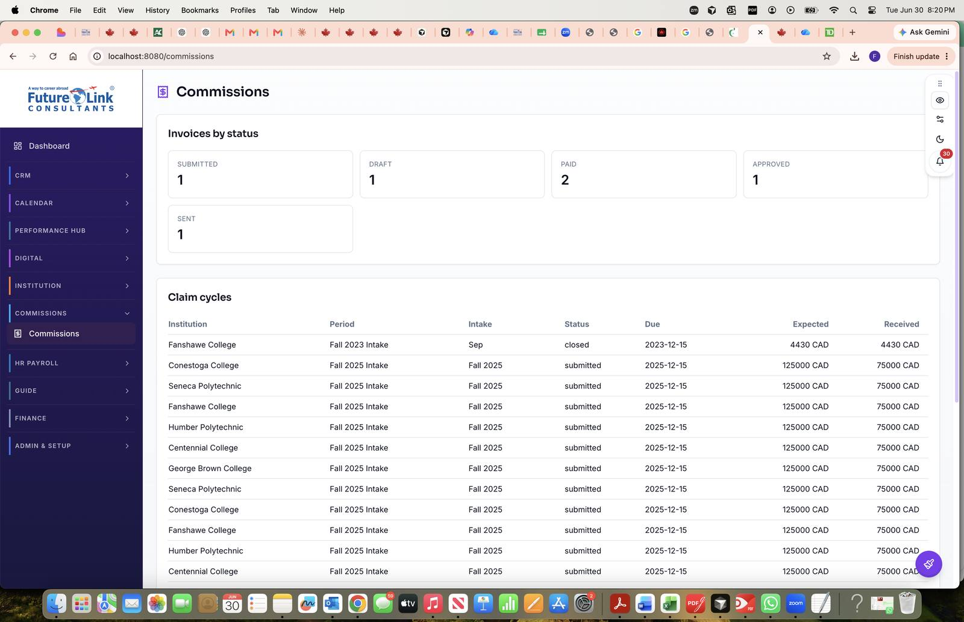
Figure 1. Global dashboard: “Invoices by status” cards (Submitted 1, Draft 1, Paid 2, Approved 1, Sent 1) over a read-only Claim cycles table. Note the summary-only design — rows are not clickable into institution workflows (see Technical Debt).

9.2 Commission plans & simulator — Institution → Commissions
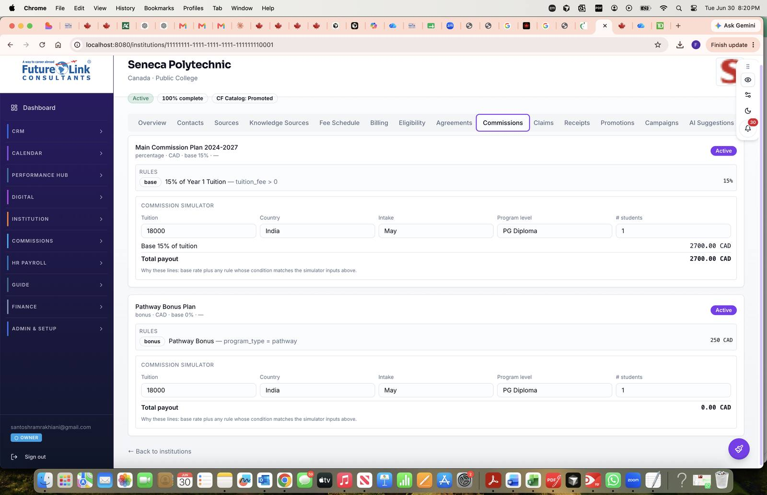
Figure 2. Two active plans for Seneca Polytechnic: a percentage “Main Commission Plan 2024–2027” (base 15%) and a “Pathway Bonus Plan” (bonus, 250 CAD on program_type = pathway). The inline Commission Simulator previews a 2,700.00 CAD payout for 18,000 tuition — client-side commissionEngine output. The bonus rule does not match the sample inputs, so its simulator shows 0.00 CAD.

9.3 Agreements — Institution → Agreements
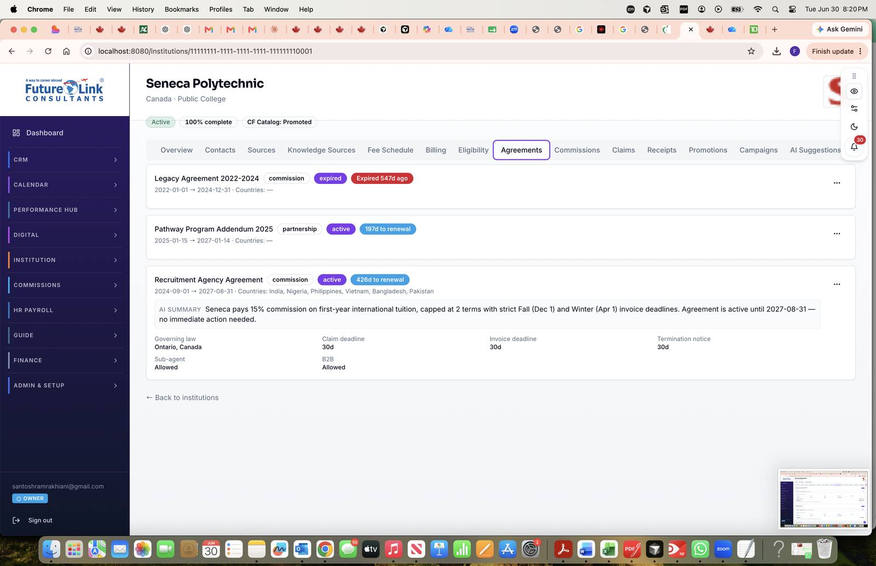
Figure 3. Agreement list with lifecycle badges (expired / active) and renewal countdowns. The expanded “Recruitment Agency Agreement” shows the upi-analyze-agreement AI summary and structured terms (governing law, claim/invoice deadlines, termination notice, sub-agent and B2B allowances).

9.4 Claims workflow — Institution → Claims
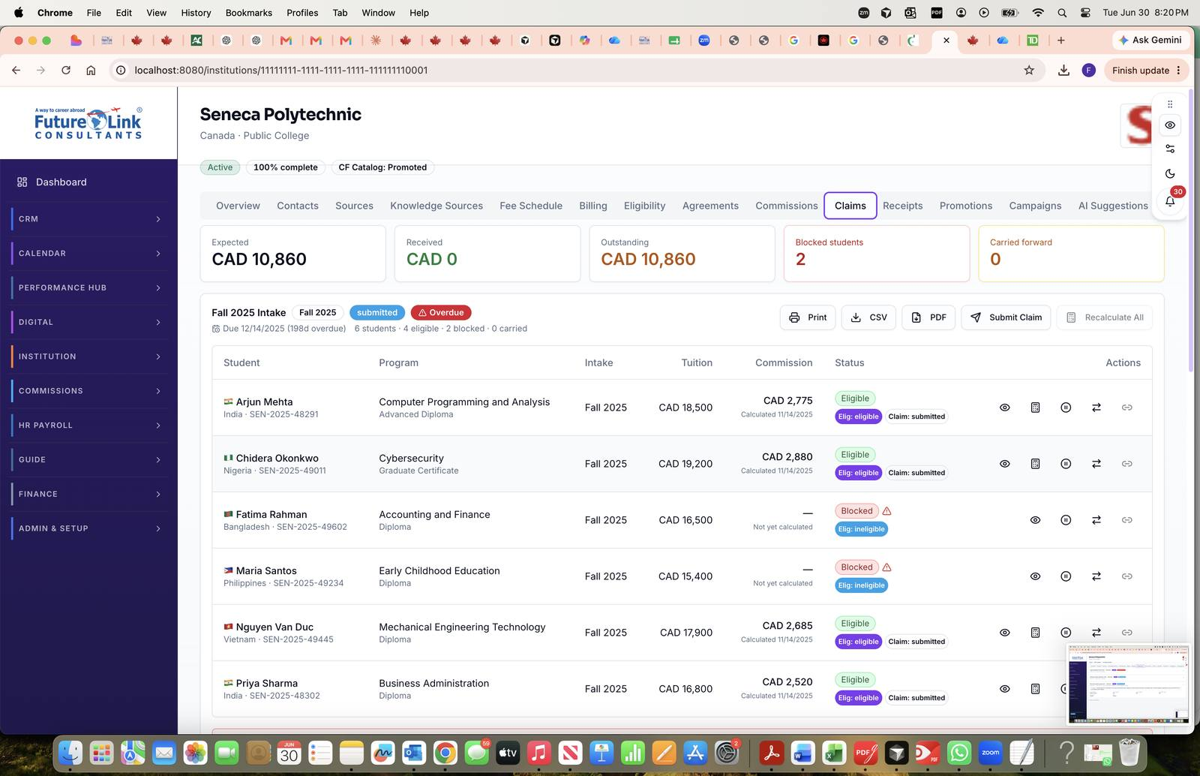
Figure 4. Claims panel for the Fall 2025 intake: KPI strip (Expected / Received / Outstanding / Blocked / Carried forward), an overdue submitted cycle, and per-student rows showing the three-axis lifecycle (Eligibility + Claim status), calculated commission, and row actions (view, recalc, hold, transfer, link). Blocked/ineligible students carry no calculated amount.

9.5 Claim submission dialog
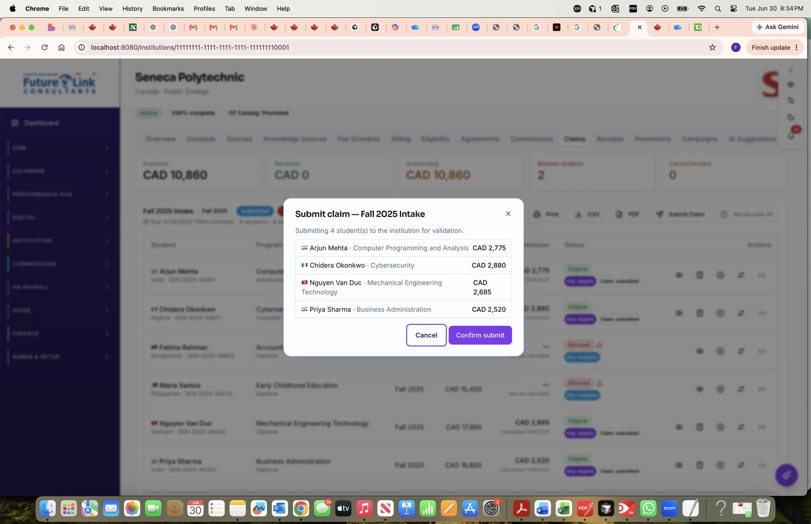
Figure 5. The Submit-claim confirmation modal lists the four eligible students and their commission amounts before the operator confirms submission to the institution for validation — an explicit, operator-initiated step (no background automation).

9.6 Receipts — empty state and creation wizard
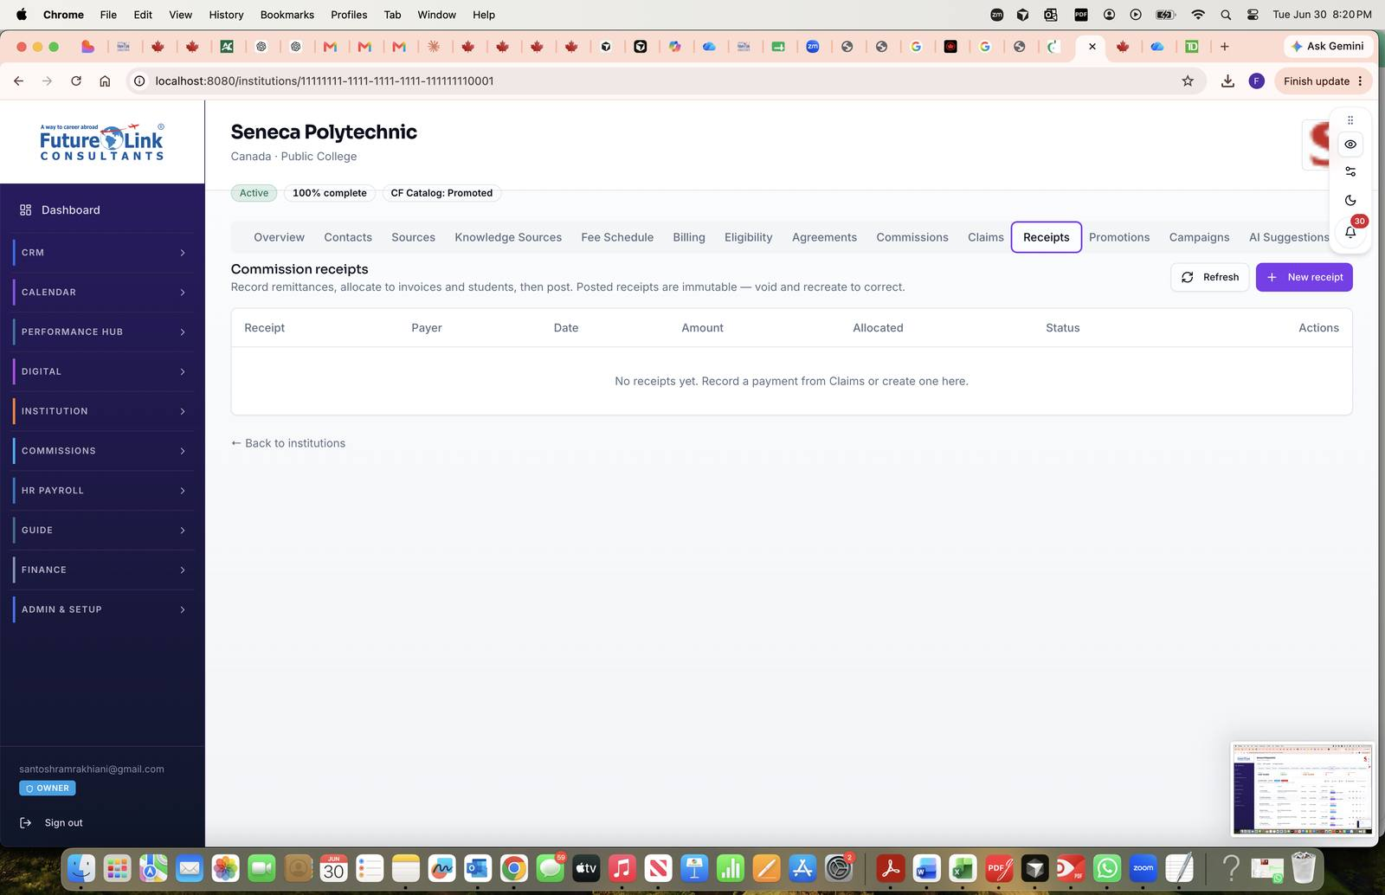
Figure 6. Receipts tab empty state, with the immutability contract stated up front: “Posted receipts are immutable — void and recreate to correct.”
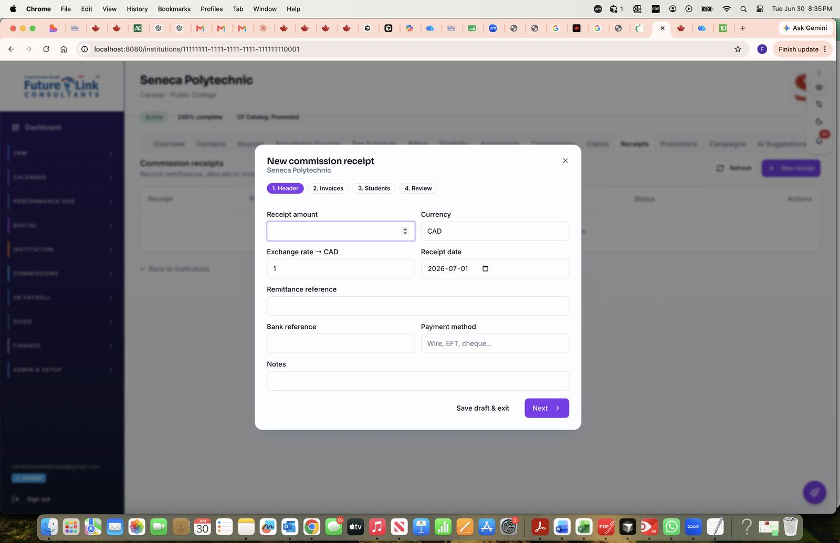
Figure 7. New commission receipt wizard, step 1 of 4 (Header → Invoices → Students → Review). Header captures amount, currency, exchange-rate-to-CAD, date, and remittance/bank references, with a “Save draft & exit” path. Steps 2–3 drive the invoice and student allocations required before posting.

9.7 Billing profile form — Institution → Billing
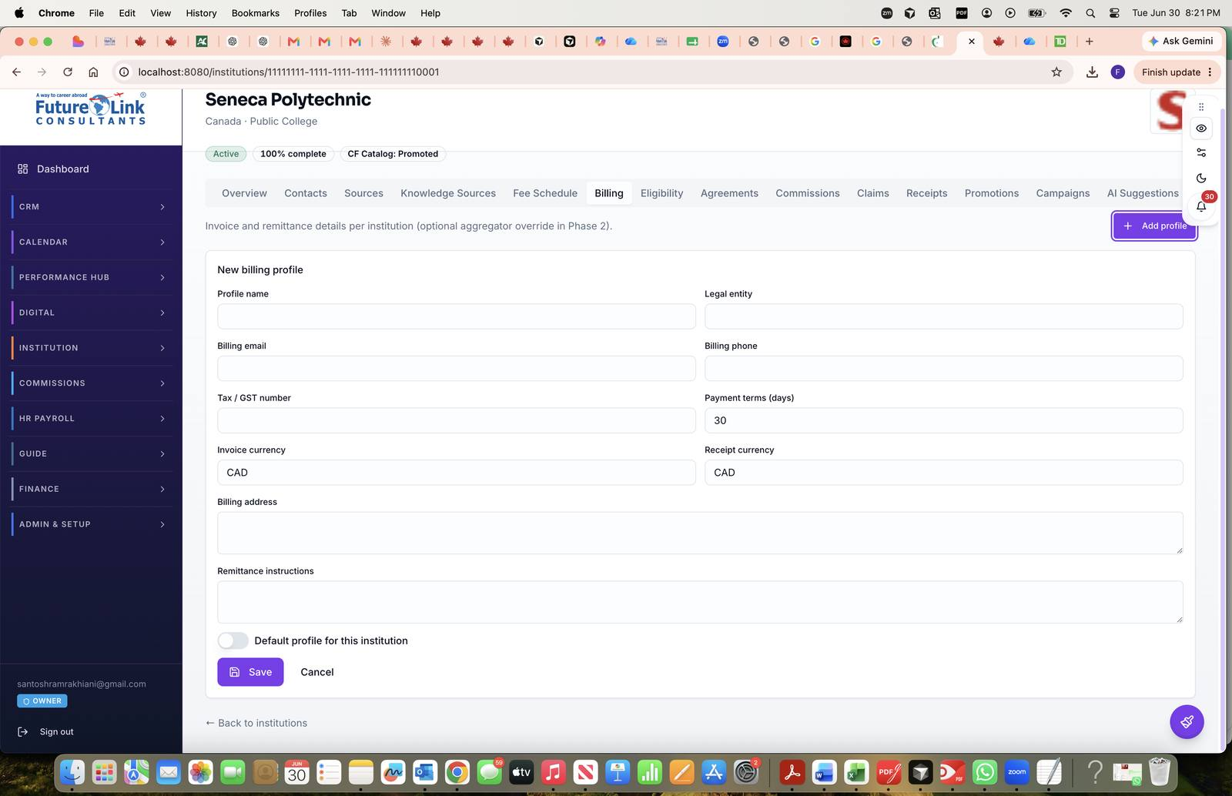
Figure 8. Billing profile creation: legal entity, billing contacts, tax/GST number, payment terms, separate invoice and receipt currencies, remittance instructions, and a default-profile toggle. The subtitle notes the optional aggregator override reserved for Phase 2.

Not captured (screens without seeded data at capture time): Aggregator Workbench (/institutions/aggregators/:id/workbench), Performance Hub ledger (/performance/commissions), and the client-detail ClientCommissionStatusPanel. Capture with an aggregator-scoped institution and Performance Hub role to complete the visual baseline.

10. Technical Debt
Every item below is tied to a source file. Types range from missing logic and placeholder UI to security and test gaps.
Item | Type | Source
Custom eligibility trigger not implemented | Missing logic | commissionEligibilityEvaluator.ts L101–103; phase1_rpcs.sql
Manual client ↔ student linking disabled | Placeholder UI | ClaimsPanel.tsx L695–700 (“Coming soon”)
CRM bridge dormant | Stub | planned/clientIntegrationBridge.ts — all TODO(activation)
Institution Claim Eligibility Rules | Backlog | docs/backlog/INSTITUTION_CLAIM_ELIGIBILITY_RULES.md
Phase 2B types missing from generated types | Type gap | types.ts vs migrations; AggregatorWorkbenchPage uses as any
Aggregator statement label “placeholder upload” | UI debt | AggregatorWorkbenchPage.tsx L483
Accounting bridge not built | Documented gap | PHASE1_UAT_READINESS; accounting_journal_id unused
Invoice auto-numbering placeholder | Known limitation | UAT doc: FLC-YYYY-AUTO-*
Legacy direct mark-paid removed | Migration note | ClaimsPanel.tsx L390 comment
Typed claim classifier deferred | TODO | claimEngine.ts L1–8 (“Phase 2.2”)
AI help doc outdated | Doc drift | ai-help/knowledge/12-commissions.md
ClaimsPanel monolith | Maintainability | ClaimsPanel.tsx (~1200 lines, mixed concerns)
Duplicate eligibility logic | Duplicate | TS evaluator + SQL RPC + dormant bridge checker
Permissive early-table RLS | Security debt | upi_commission_students policy (authenticated USING true)
No E2E tests for commission workflows | Test gap | Only 5 unit-test files present
Global dashboard has no navigation | UX gap | CommissionsPage.tsx — lists only, no links

11. Reuse Analysis (Evidence-Based)
Each major feature is classified KEEP AS IS, IMPROVE, CONSOLIDATE, REMOVE, or REBUILD, based only on observed implementation. The guiding principle is preserve-and-extend rather than replace.
Feature | Classification | Reason • affected if changed
Commission rule engine (engine + resolver) | KEEP AS IS | Pure, unit-tested, mirrors DB RPC • recalc, simulator, future API
Phase 1 lifecycle RPCs | KEEP AS IS | UAT-ready, immutability triggers • all lifecycle UI
Institution tab workspace | KEEP AS IS | Full operational workflow in one place • institution module
Receipt wizard + RPCs | IMPROVE | Works per 2A; no GL bridge • finance, accounting
Global /commissions dashboard | IMPROVE | Read-only summary • needs drill-down, filters, pending claims
ClaimsPanel monolith | CONSOLIDATE | Extract sub-components without behavior change • claims maintenance
clientIntegrationBridge | REBUILD | BRIDGE_ENABLED=false, all TODOs • CRM, admissions
Dormant bridge eligibility checker | REMOVE / merge | Overlaps Phase 1 evaluator • conflicting-rule risk
Legacy commission_status column | KEEP (for now) | Trigger keeps legacy UI working • backward compatibility
Phase 2B as any table access | IMPROVE | Regenerate Supabase types • aggregator workbench
Performance Hub CMS view | KEEP AS IS | Delegates ops to /commissions • finance reporting
upi_invoices vs upi_commission_invoices | CONSOLIDATE (future) | Two invoice concepts • billing confusion risk
Custom eligibility trigger | REBUILD | Returns false always • needs product spec first
Institution Claim Eligibility Rules | CREATE (future) | Backlog only • claims validation
Referral / B2B commissions | CREATE (future) | No tables/routes • new domain

12. Extension Points
What already exists in the architecture as a seam for future channels and integrations, versus what is missing.
Extension | Exists | Evidence • what’s missing
Multi-country commissions | Partial | scope_country on rules; country_of_origin on students • per-country eligibility rules
Multi-currency | Partial | Currency columns + FX review • consolidation limited to PH INR view
Multi-company / entity | Partial | Billing profiles; accounting entity_id • commission→entity mapping Not Found
Aggregator commissions | Yes | Phase 2B tables, workbench, aggregator invoices • type generation
Agent commissions | Not Found | No agent-specific tables/routes
Team commissions | Not Found | Staff incentives are a separate module
Referral commissions | Not Found | PH subtitle text only; no tables
B2B commissions | Not Found | Agreement flag only; no tables
Incentives / bonuses | Partial | bonus as rule_type • separate engine out of scope
Performance Hub integration | Yes | /performance/commissions ledger • bidirectional sync Not Found
Finance integration | Partial | accounting_journal_id reserved • journal creation Not Found
CRM event automation | Stub | clientIntegrationBridge.ts • activation + implementation
CAE integration | Partial | upi_agreements, commission_partner settlement • flow unverified
AI commission extraction | Yes | upi-extract-commission-sheet edge function
Clawback | Schema only | clawback_amount/status columns • logic Not Found
Credit notes | Not Found | Documented out of scope

13. Cross-Module Dependencies
The Commission module is hosted by the Institution module and reads from / writes to several others. Solid arrows are live; dotted arrows are planned or reserved.
Institution ── hosts tabs, routes, aggregators ──▶ Commission
Commission ── client_id FK, status view ──▶ CRM / Clients
Admissions ·· planned bridge only ··▶ Commission
Commission ·· accounting_journal_id unused ··▶ Finance
Commission ── ledger read ──▶ Performance Hub
Auth/RBAC ── isCommissionAdmin, confidential RLS ─▶ Commission

Module | Data / trigger | Failure impact
Institution | institution_id, routes, aggregators, documents | Commission UI inaccessible without institution
Student / Client | client_id, v_client_commission_status | Counselors see no status if unlinked
Admission | Planned bridge (application_submitted) — not active | No auto student-row creation
Finance | Receipt amounts; reserved journal FK | Manual reconciliation required
Performance Hub | Aggregated student amounts, FX | Oversight view empty/stale
Users / Roles | Commission admin, accounting member, module perms | Tab lock / access denied
Documents | commission_sheet, agreement doc kinds | Rules not auto-created from sheets
CAE | Agreements, settlement eligibility | Adjacent; not primary commission path
Incentives | Shared PH nav shell only | Separate domain (staff vs partner)
Notifications | Not Found commission-specific | —
Reporting | KPI tooltip references claim cycles | No dedicated commission reports

14. Deliverables Summary & Handoff Notes
This document is the implementation baseline for the Commission module in flow-link-docs. It covers all fourteen audit areas: executive summary, database, business process, backend, frontend, business logic, API inventory, component inventory, UI (now with captures), technical debt, reuse analysis, extension points, and cross-module dependencies.

14.1 Key takeaways for an incoming architect
- Terminology: “Commission Plan” = upi_commissions; there is no separate plan entity.
- Architecture: Supabase RPC-centric backend; the React institution-tab workspace is the operational core; all writes go through SECURITY DEFINER RPCs.
- Phases delivered: Phase 1 (lifecycle), 2A (receipts), 2B (aggregator) — evidenced by migrations 20260723120000 through 20260815120500 and the corresponding UI.
- Explicit gaps: Finance GL bridge, CRM automation, custom eligibility, claim eligibility rules, global admin/reports/pending-claims screens, and referral/B2B/agent commission types.
- Reuse principle: Preserve commissionEngine, the rule resolver, Phase 1 lifecycle RPCs, the receipt allocation model, and the institution-tab structure; extend rather than replace.

14.2 Reference artifacts in the handoff package
- TECHNICAL_INVENTORY.md — source audit this document is built from.
- docs/database/COMMISSION_SCHEMA.sql — concatenated DDL + RPC migrations.
- docs/database/RPC_INDEX.md — full RPC listing by phase.
- docs/architecture/15_commissions-er.mmd — ER diagram (Mermaid).
- docs/guides/PHASE*_COMMISSION_*.md — UAT guides and design docs.
- docs/integration/ — AppRoutes, AppLayout, and InstitutionDetailPage integration excerpts.

14.3 Audit constraints honored
No code was modified. No redesign was proposed. No refactoring or new architecture was recommended beyond documenting existing limitations. All conclusions are tied to observed files, migrations, and documentation; behavior that could not be verified is marked “Not Found” rather than inferred. The UI section has been completed with screenshots supplied from the running application, replacing the earlier “not captured” placeholder.

